**Day-5 session-5(16/08/2024)  
Step-1:**  Changing the path by using **cd /etc/yum.repos.d**

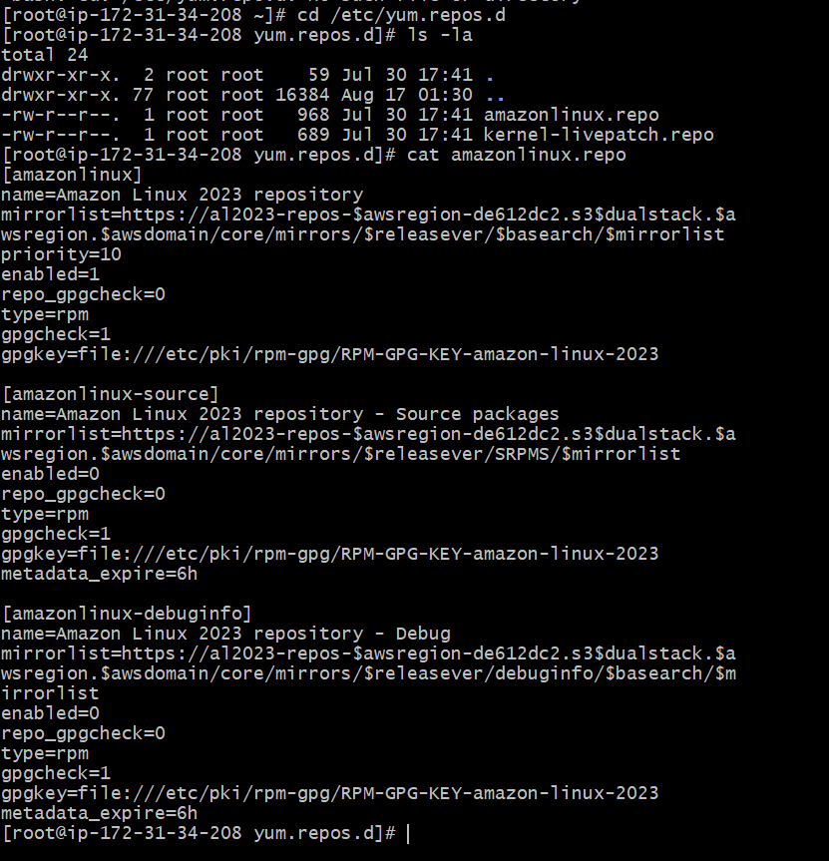

**Step-2:** Install Git 🡪 dnf install git -y

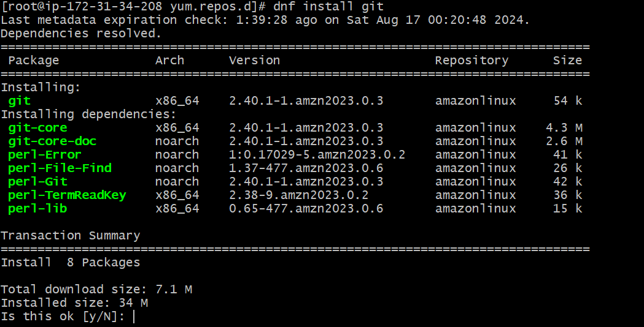

**Step-3:**  List out the packages what are all installed 🡪 dnf list installed

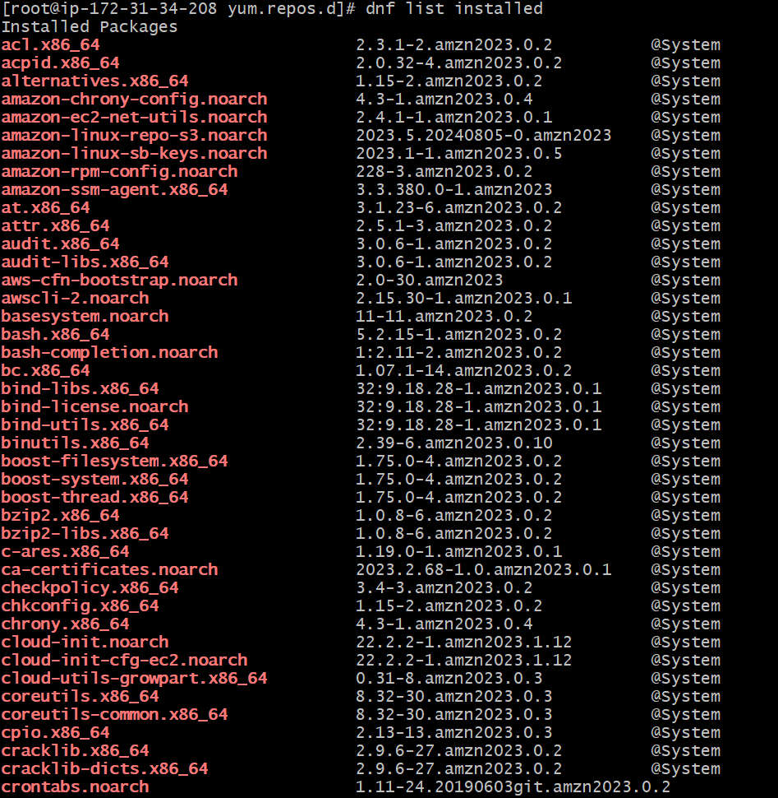

**Step-4**: Counting the installed files and available packages

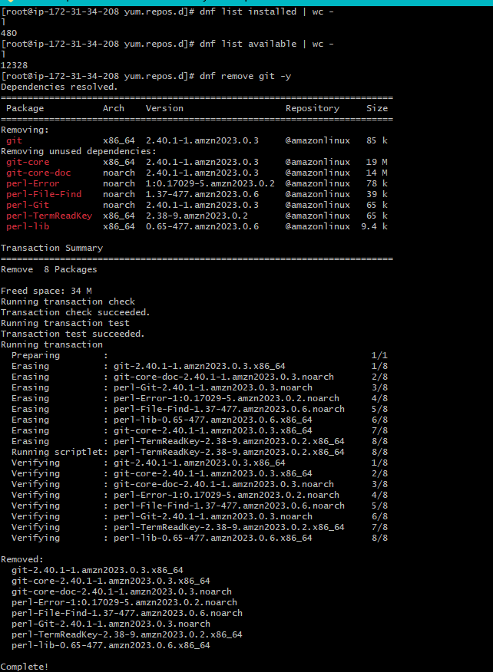

**Step-5:**   
 How can you check cpuinfo, memory info, OS?  
 **🡪** CPU information we can find in,

**cat /proc/cpuinfo**

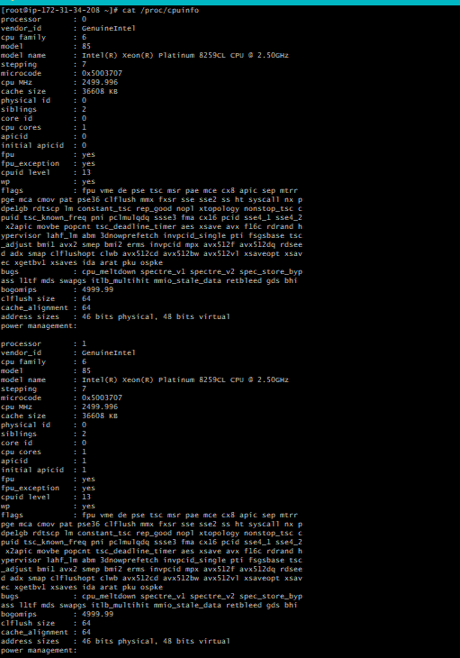

* Memory information is in **cat /proc/meminfo**

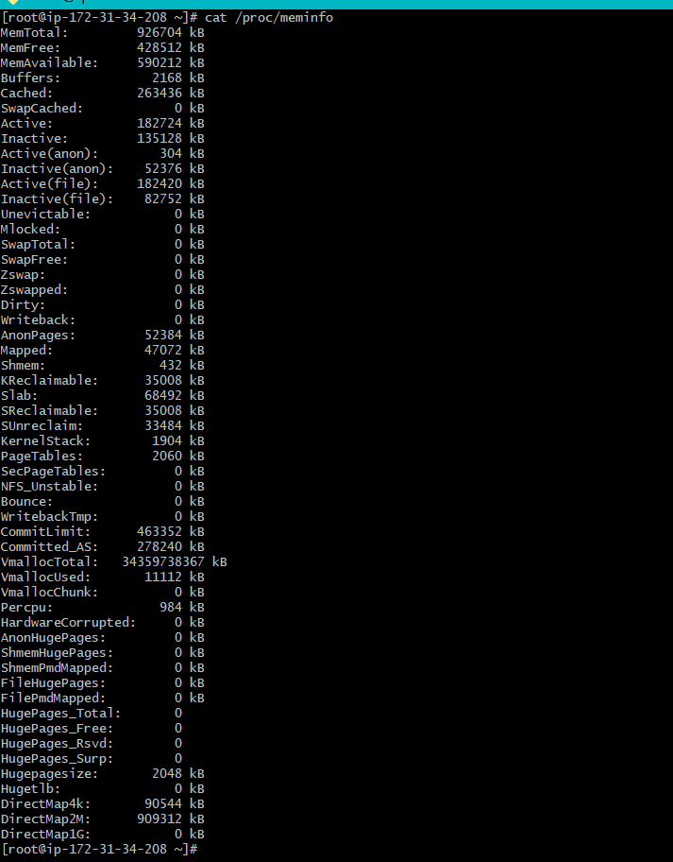

* OS information is in 🡪 **cat /etc/os-release**

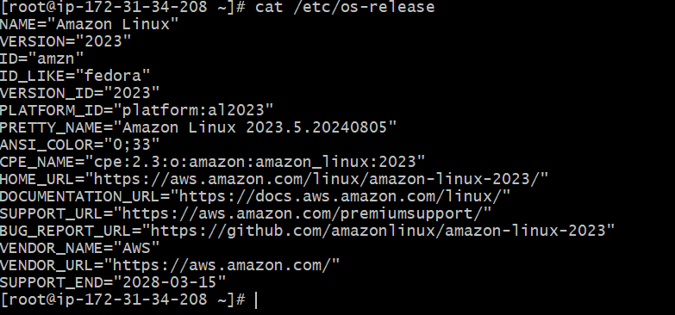

**Step-6**: check the status

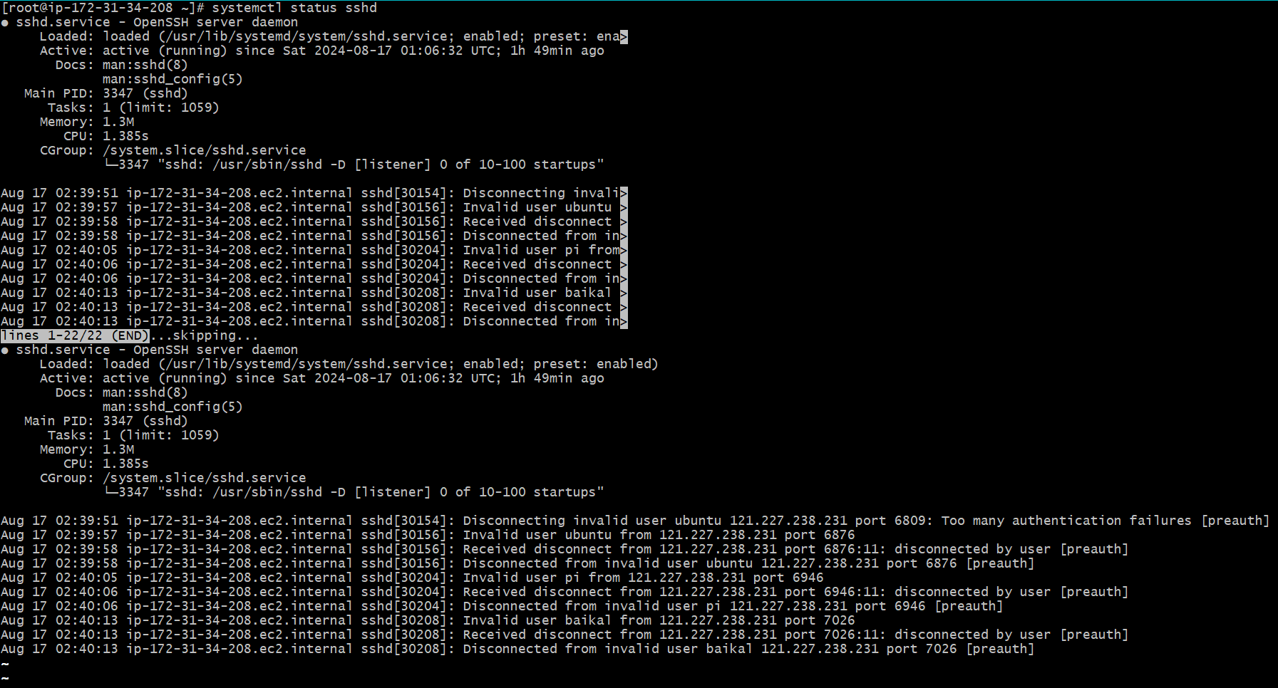

**Step-7:** Install the nginx

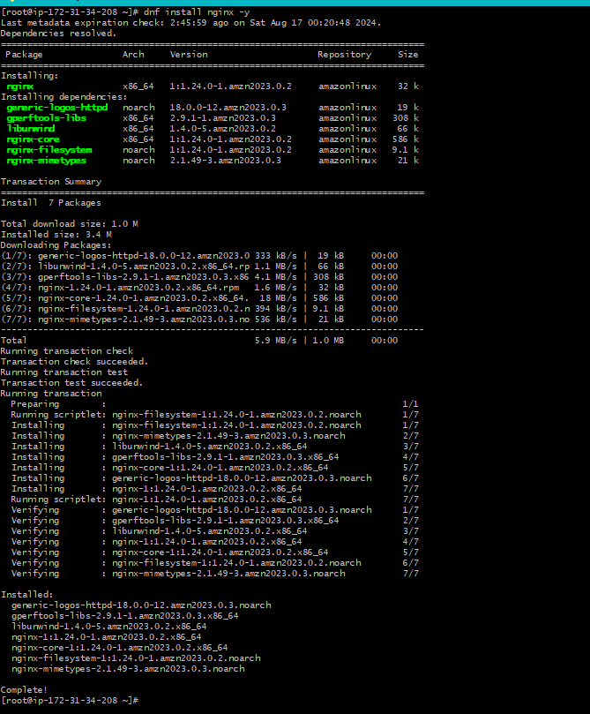

**Step-8**: Start the Nginx package

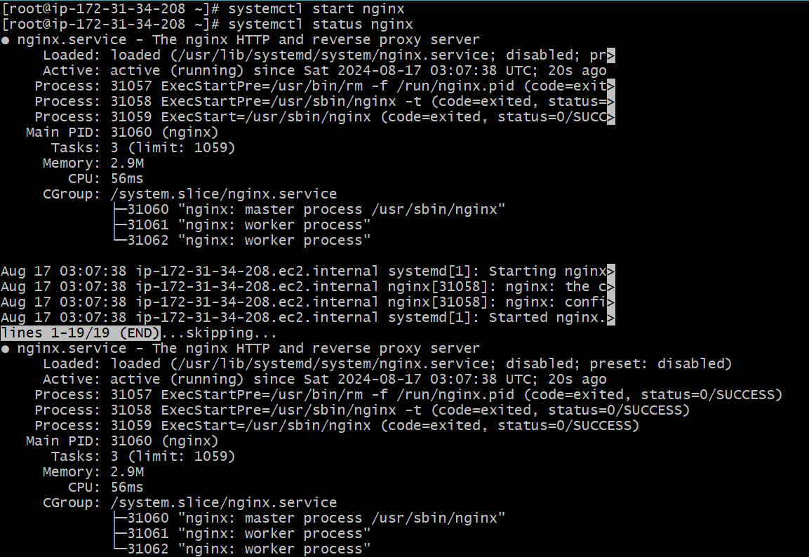

**Step-9**: Display this with the Public IP address of frontend

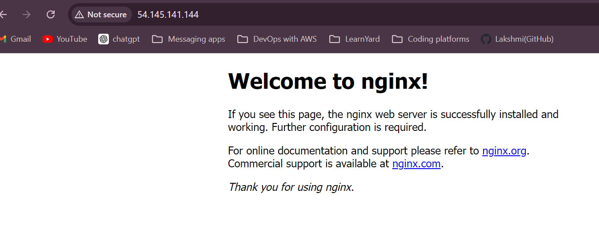

**Step-10**: Start the nginx and enable the nginx

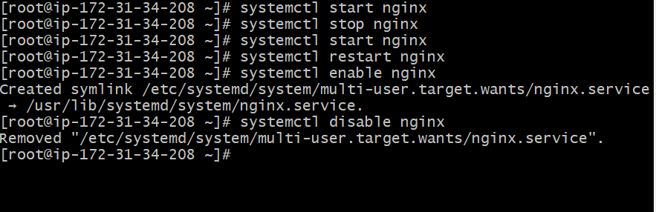

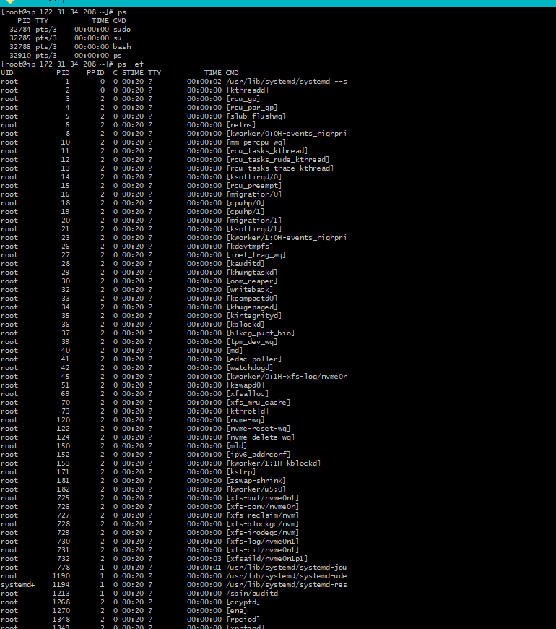

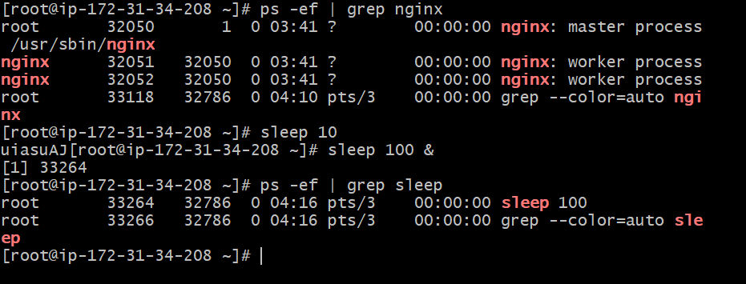

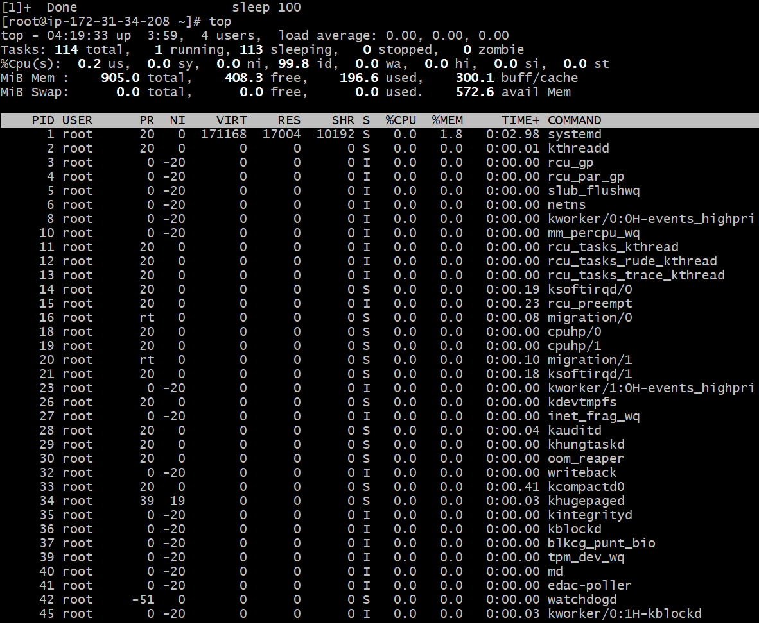

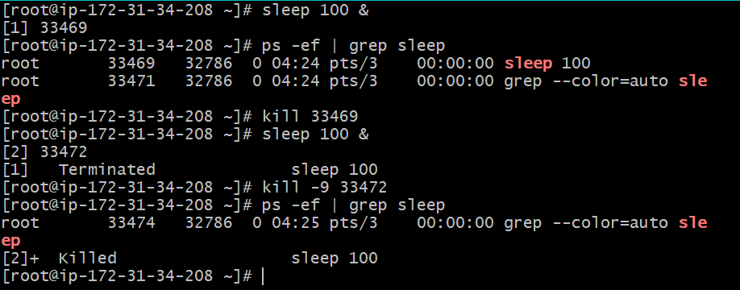

* Networking commands

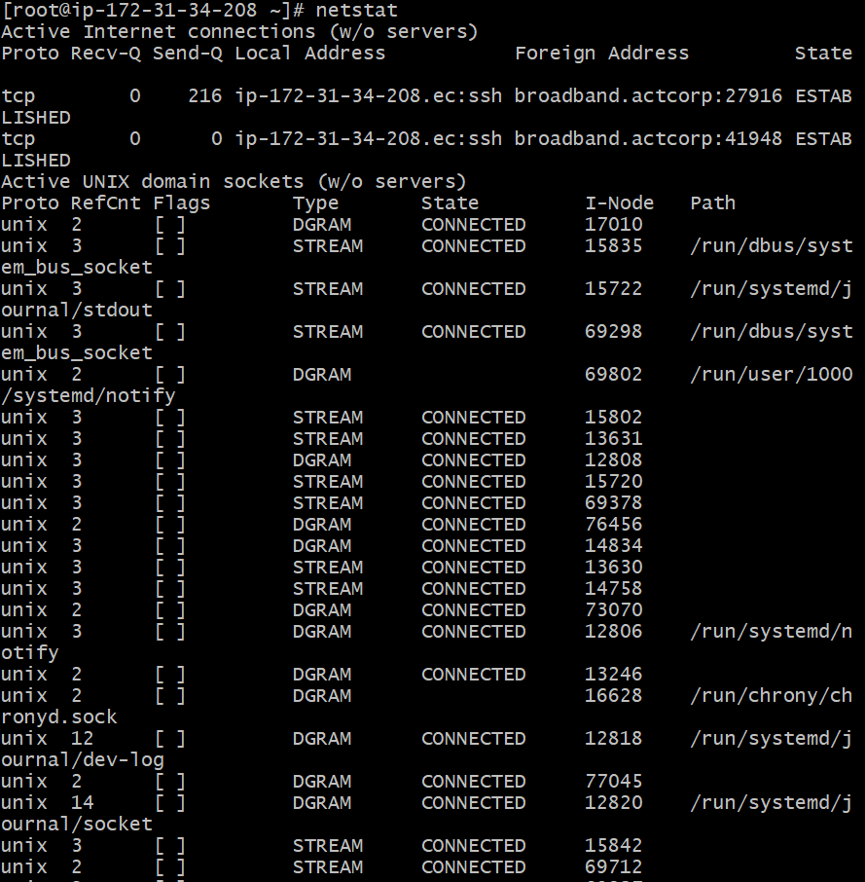

* Checking if the port number is opened or not and listing out

